**Practical no. 2**

**FS19CO042**

**Aim:** Draw network layout and type of topology used for computer lab networking.

**Tool used:** Cisco Packet tracer student software.

**Required components:** PCs, Laptops, switches, routers

**Theory and steps:**

**Topology**

It defines physical or logical arrangement of links in network. Topology is

physical **layout** of **computers, cables and other connected devices** on a network. The

term topology refers to the way a network is laid out either physical or logically two or

more devices connect to a link or more links form a topology. The topology of a network

is the geometric representation of the relationship of all the links and linking devices

(called node) to each other.

There are two classifications of topologies-

1. Physical Topology

2. Logical Topology

**Physical topology**

The complete physical structure of transmission media is called physical topology. This refers to the layout of cabling, location of nodes and interconnection between the nodes and cabling.

**Logical Topology**

The logical topology is refers to how data is actually transferred in a network. This represents the way that data passes through the network from one device to another.

**Different types of topologies are:**

a. Bus Topology

b. Ring Topology

c. Star Topology

d. Mesh Topology

e. Tree and Hybrid Topology

**Star Topology :**

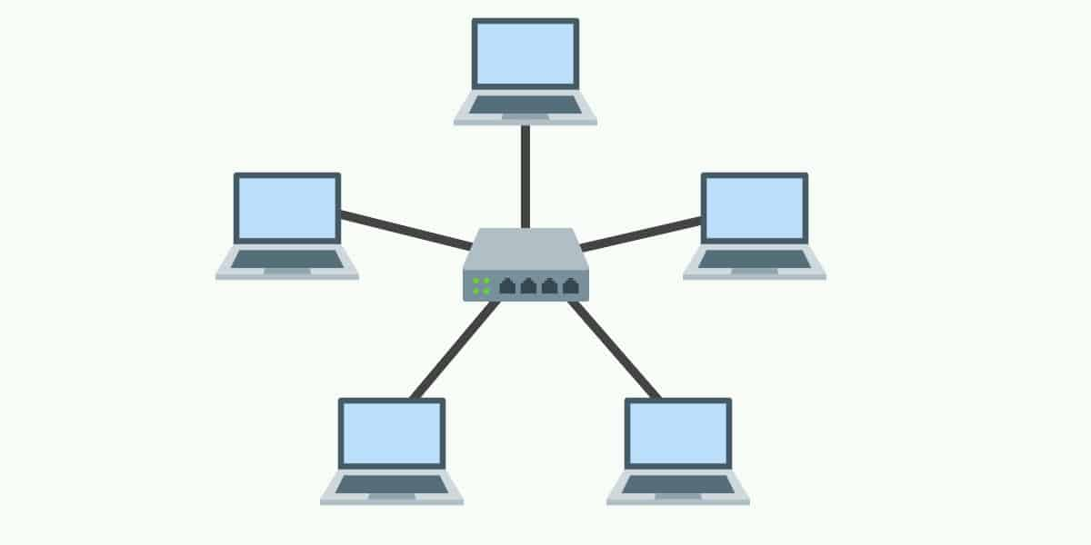

Physical star topology uses a central device or controller with drop cables extending in all direction. The devices are not directly linked to one another. Each network device is connected via point-to-point link to central device called ‘**HUB**’ multipoint

repeater or concentrator. The controller acts as an exchange: If one device wants to send data to another, it sends the data to the controller, which then relays the data to the other connected device.

When network expansion is expected and a greater reliability is expected then star topology is needed.

**Advantages of Star topology**

1. Less expensive because each device only need one I/O port and needs to be connected with hub with one link.  
2. Easier to install  
3. Less amount of cables required because each device needs to be connected with the hub only.  
4. Robust, if one link fails, other links will work just fine.  
5. Easy fault detection because the link can be easily identified.

**Disadvantages of Star topology**

1. If hub goes down everything goes down, none of the devices can work without hub.  
2. Hub requires more resources and regular maintenance because it is the central system of star topology.

Steps for configuring Star Topology in Cisco Packet Tracer :

1. To configuring Star Topology you will need a central device. You can select Network Switch from toolbox present at the bottom of Cisco Packet Tracer. From toolbox, select the option containing Switches. Select Desired Network model and drag and drop it on drawing area  
   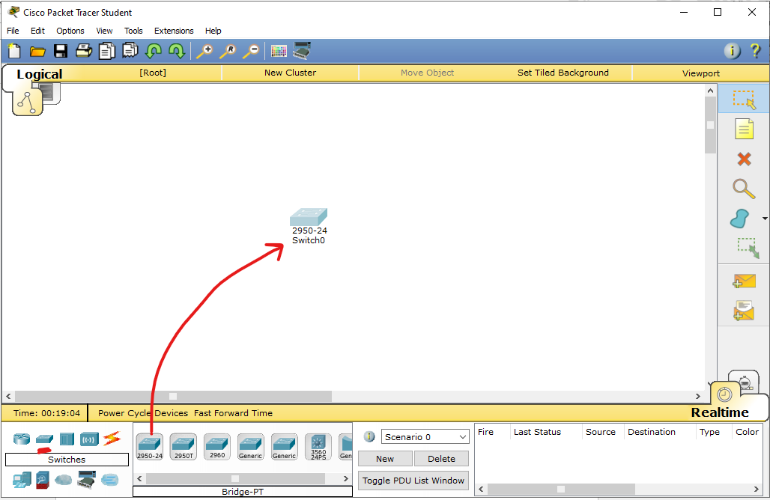
2. Select End devices for your Network, End devices may include PC, Laptop, Printer, etc; Now drag and drop all the end devices you want on drawing area  
   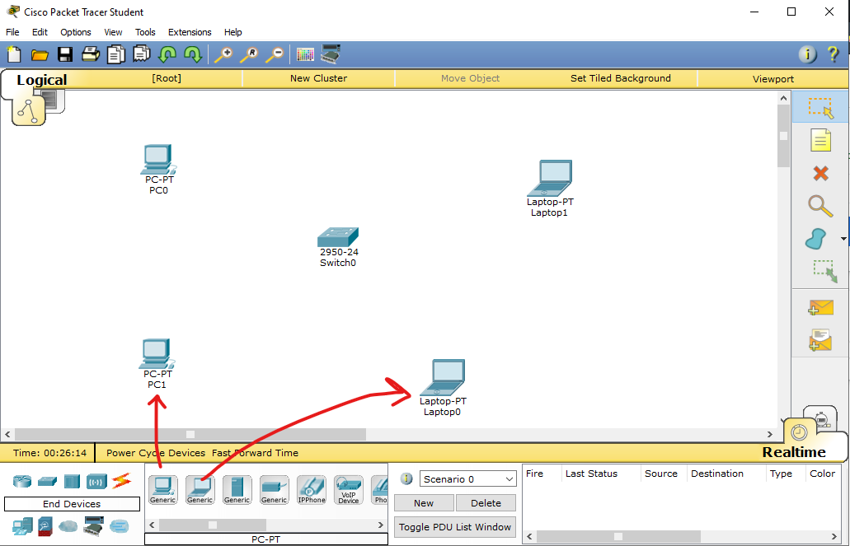
3. Choose Connecting cable for Device connections, For this go to connections menu from toolbox and select **Copper Straight Through Cable**   
   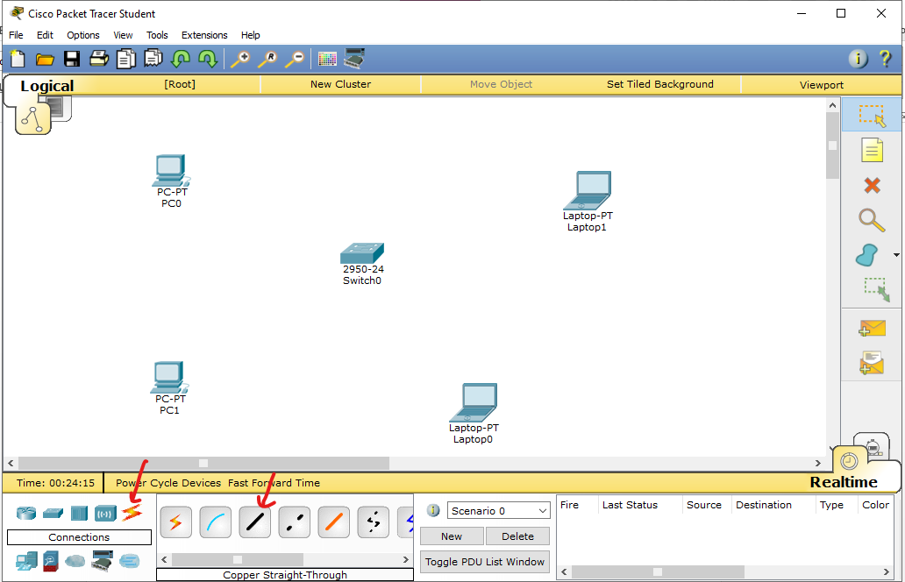
4. For initiation of connections, first of all you will need to click **‘Copper Straight Through** **Cable’**. After clicking it you will see that your mouse pointer has changed its icon. Move the pointer to the end device and click on it. You will see a menu appearing right close to the computer. It will be displaying two options: 1) RS 232 and 2) Fast Ethernet. Choose the second option

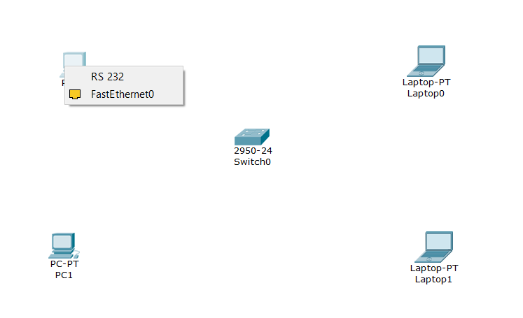

1. To complete connection of an end device, move mouse pointer to a switch and click on it. You will be seeing a list of options. Each option represent a switch port. Click on Fast Ethernet option for completing connections.

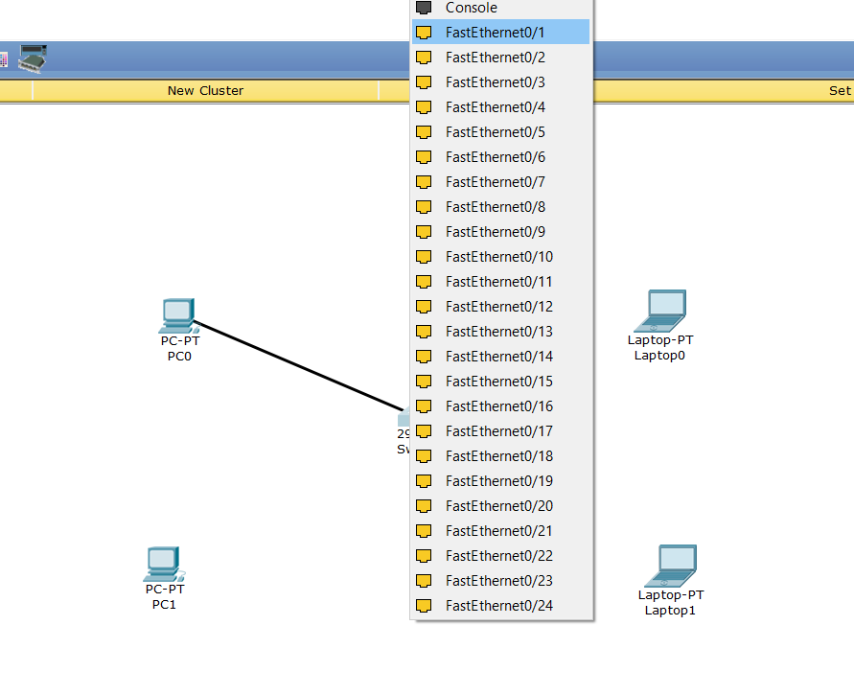

1. To connecting all the devices repeat step 4 & 5 for all the remaining end devices

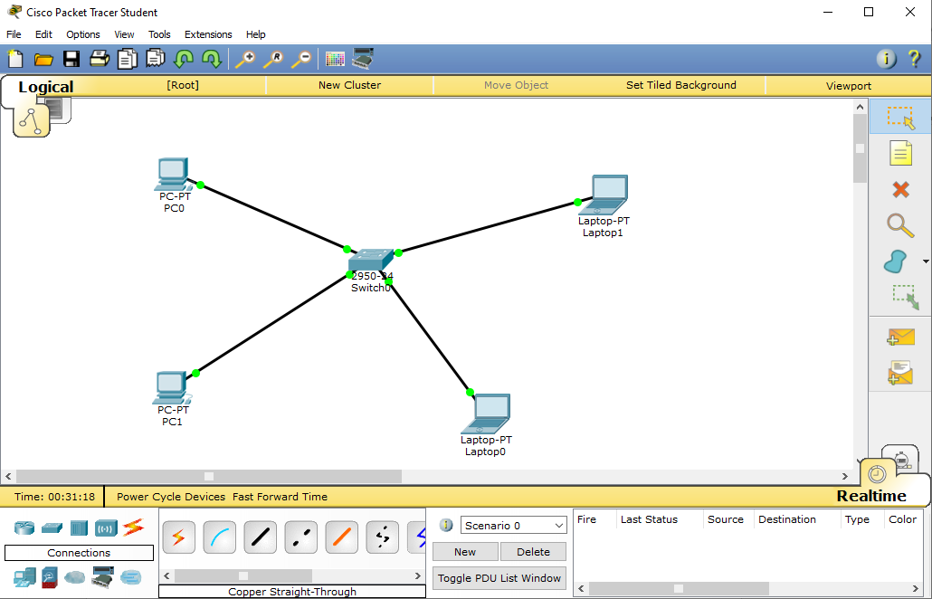

**Ring Topology**

In this topology, it forms a ring connecting devices with its exactly two neighboring devices. A number of repeaters are used for Ring topology with a large number of nodes, because if someone wants to send some data to the last node in the ring topology with 100 nodes, then the data will have to pass through 99 nodes to reach the 100th node. Hence to prevent data loss repeaters are used in the network. The transmission is unidirectional, but it can be made bidirectional by having 2 connections between each Network Node, it is called Dual Ring Topology.

**Advantages of Ring Topology**

1. Easy to install.  
2. Managing is easier as to add or remove a device from the topology only two links are required to be changed.

**Disadvantages of Ring Topology**

1. A link failure can fail the entire network as the signal will not travel forward due to failure.  
2. Data traffic issues, since all the data is circulating in a ring.

**Layout**

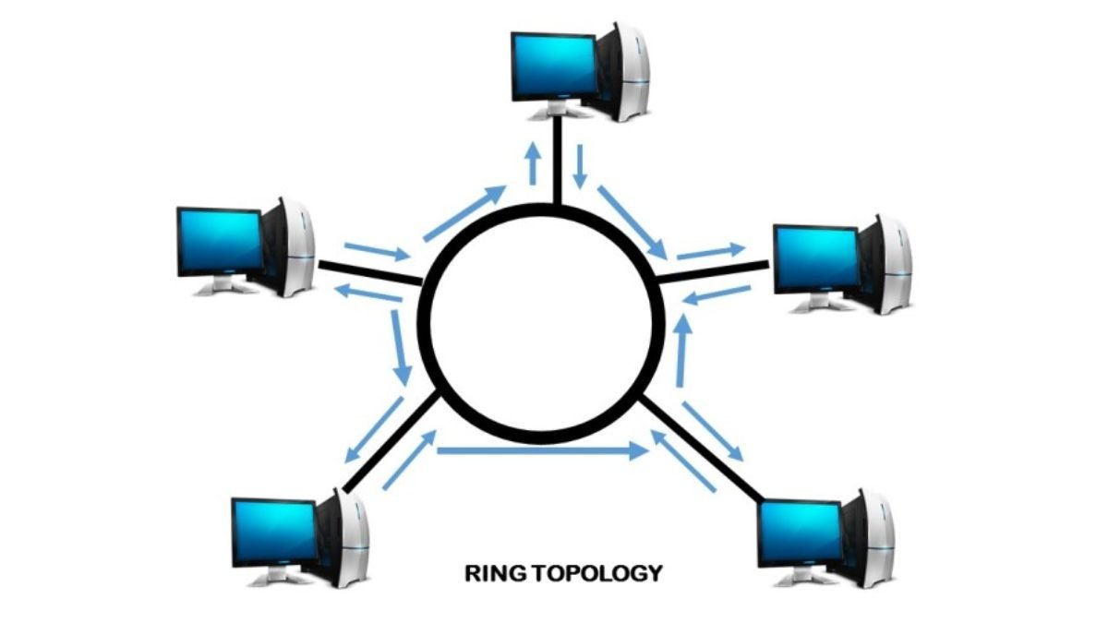

**Steps to connect**

1. Put end devices like PC laptops on logical view and connect it to a switch respectively by copper straight cable.  
   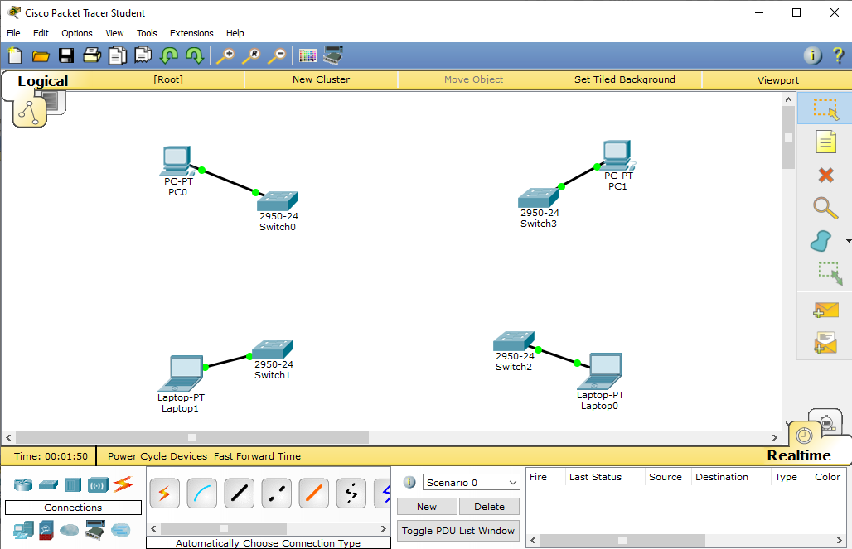
2. Connect each switch to its 2 adjacent switches such that every switch is connected to only 2 adjacent switches by a copper-cross over cable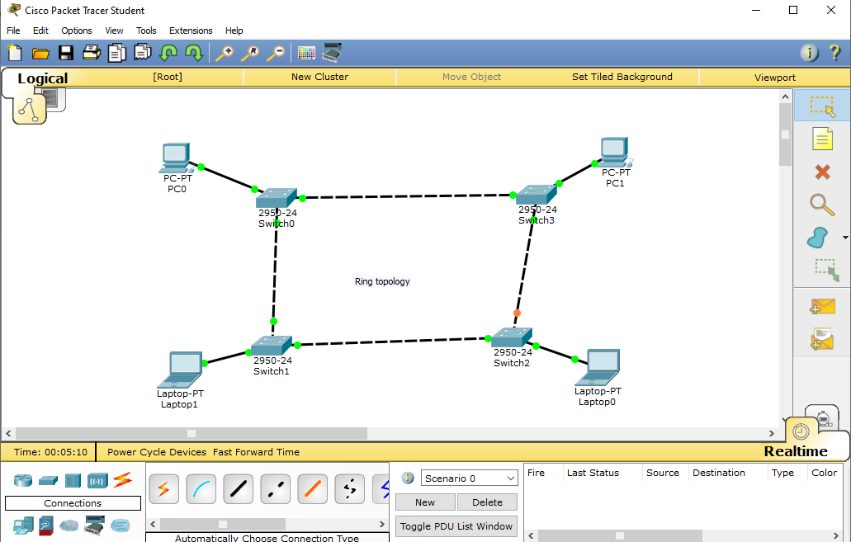

**Mesh Topology :**

In mesh topology, every device is connected to another device via particular channel. If suppose, N number of devices are connected with each other in mesh topology, then total number of ports that is required by each device is ? N-1. In the Figure 1, there are 5 devices connected to each other, hence total number of ports required is 4. If suppose, N number of devices are connected with each other in mesh topology, then total number of dedicated links required to connect them is NC2 i.e. N(N-1)/2. In the Figure 1, there are 5 devices connected to each other, hence total number of links required is 5*4/2 = 10.

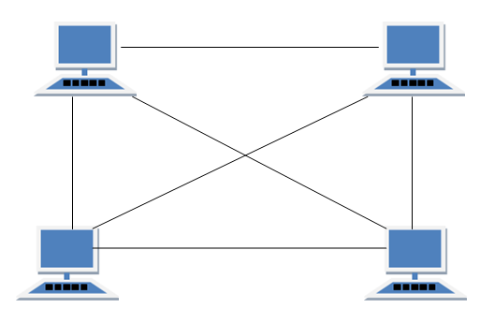

**Advantages of Mesh topology**

1. No data traffic issues as there is a dedicated link between two devices which means the link is only available for those two devices.  
2. Mesh topology is reliable and robust as failure of one link doesn’t affect other links and the communication between other devices on the network.  
3. Mesh topology is secure because there is a point to point link thus unauthorized access is not possible.  
4. Fault detection is easy.

**Disadvantages of Mesh topology**

1. Amount of wires required to connected each system is tedious and headache.  
2. Since each device needs to be connected with other devices, number of I/O ports required must be huge.  
  
Connection steps:

* Put end devices on view connecting each to a switch respectively.
* Connect each switch to every other switch by a cross-over cable such that every switch can send/receive data to and from every other switch directly.

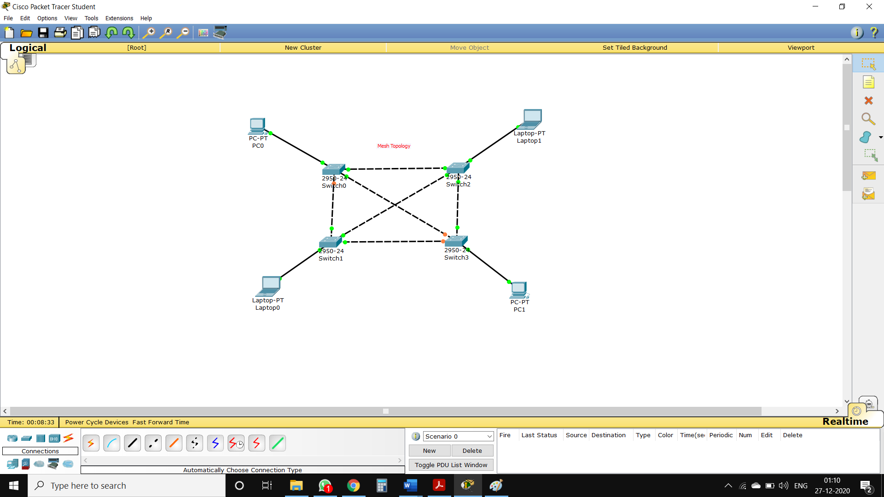

**Bus Topology :**

Bus topology is a network type in which every computer and network device is connected to single cable. It transmits the data from one end to another in single direction. No bi-directional feature is in bus topology

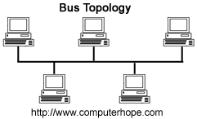

**Advantages of bus topology**

1. Easy installation, each cable needs to be connected with backbone cable.  
2. Less cables required than Mesh and star topology

**Disadvantages of bus topology**

1. Difficultly in fault detection.  
2. Not scalable as there is a limit of how many nodes you can connect with backbone cable.

**Connection steps:**

* Put end devices on view connecting each to a switch respectively.
* 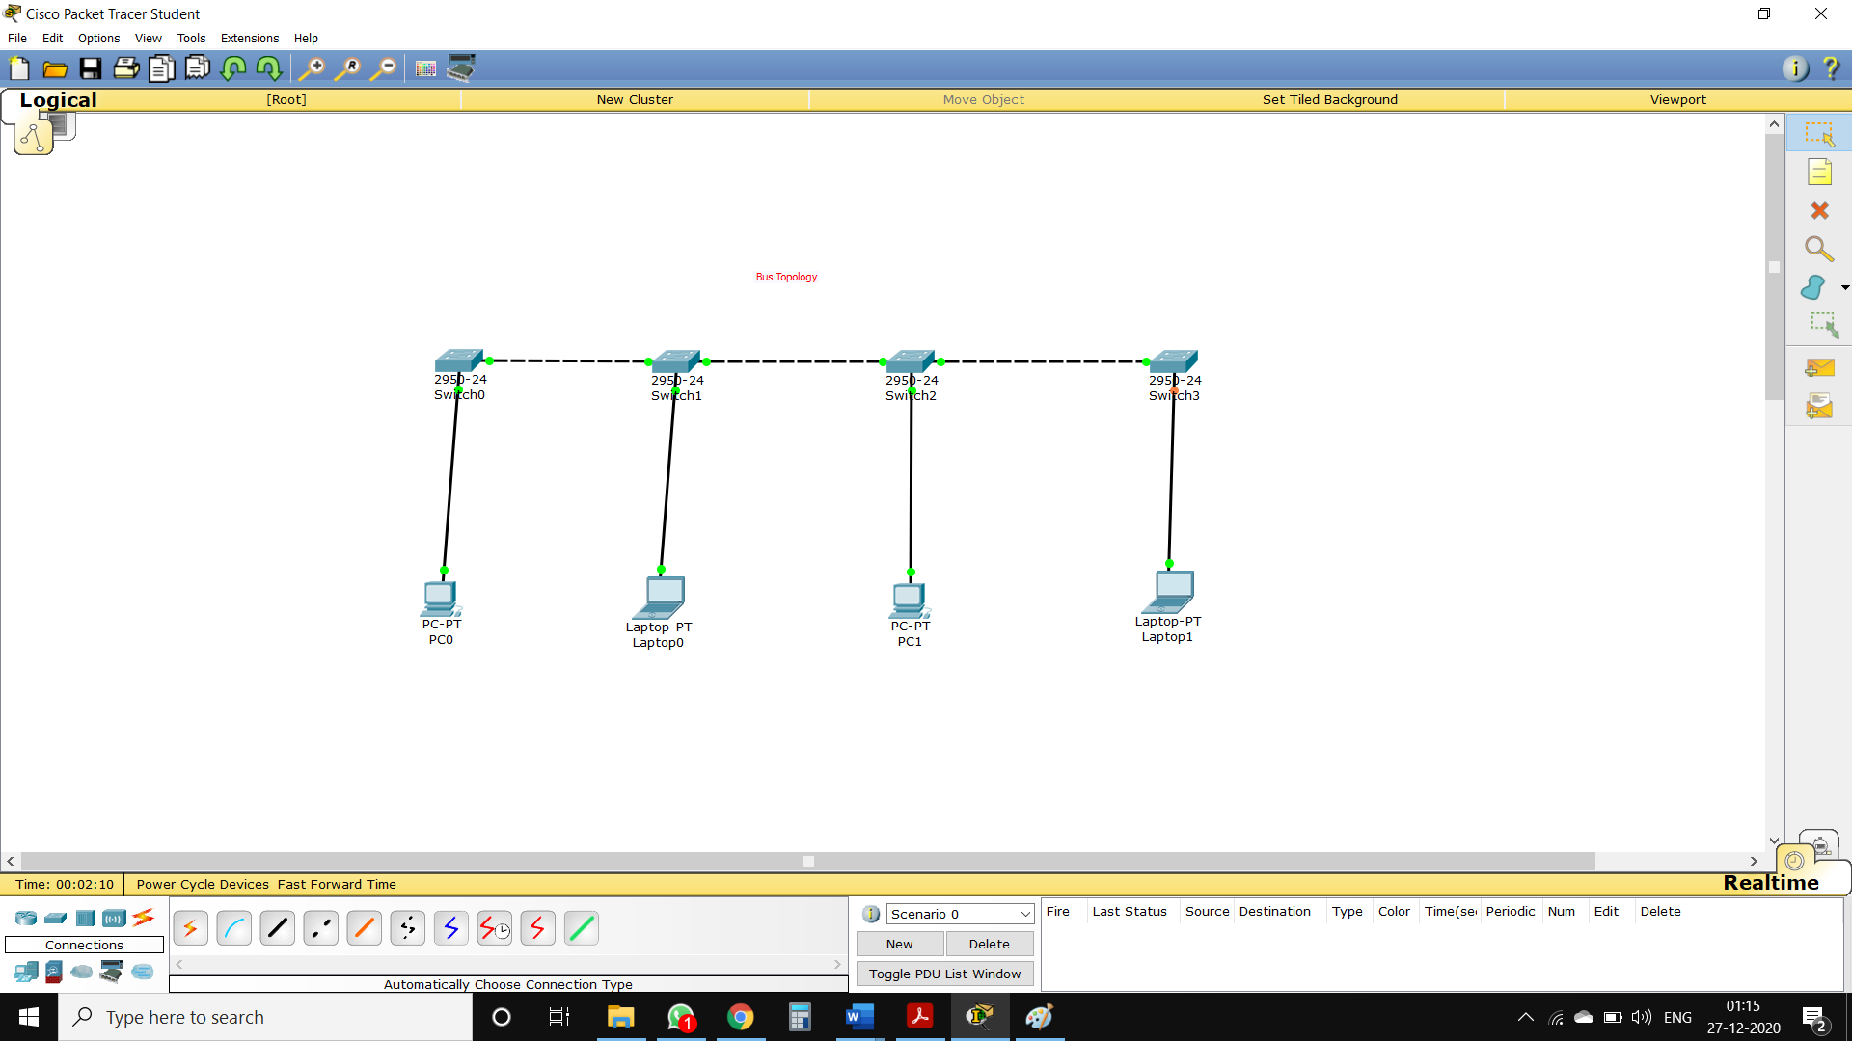Connect each switch to 2 of its adjacent switch exception: terminal switches should have only one other switch connected, thereby avoiding ring and forming a bus topology.

**Tree Topology**

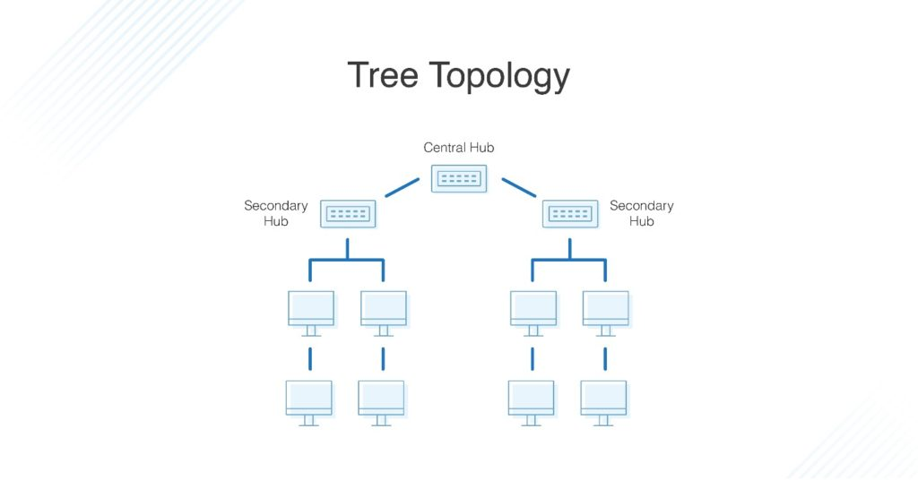This topology is the variation of Star topology. This topology have hierarchical flow of data. Click to enlarge here various secondary hubs are connected to the central hub which contains the repeater. In this data flow from top to bottom i.e from the central hub to secondary and then to the devices or from bottom to top i.e. devices to secondary hub and then to the central hub.

Advantages of tree topology

1. **HIGHLY FLEXIBLE:** In tree topology computers can be added by simply adding a hub in a network topology.
2. **CENTRALISED MONITORING:** It makes users to control and manage a larger network easily and also it is easy to reconfigure the tree topology.
3. **COMPUTERS HAVE ACCESS:** Because tree topology is a large network, all computers have better access to the network.
4. **POINT-TO-POINT CONNECTION:** In tree topology each computer is connected to the hub and also each part of a network is connected to the main cable.
5. Tree topology is supported by many hardware and software venders.
6. In tree topology it is easy to add a computer by simply extending using cables to connect computers.

Disadvantages of tree topology

* **SINGLE POINT OF FAILURE:** In tree topology, if the backbone of the entire network breaks both part of the network may not communicate to each other but a part of the network continues to communicate alone.
* **DIFFICULT TO CONFIGURE:** It is difficult to configure tree topology because is a large topology and also wiring the network is difficult.

In tree topology, the length of the network is limited by the type of cable to be used on the network.

**USAGE OF TREE TOPOLOGY**

tree topology has some usage such as:

It is easy to identify the system in the network and also connect to a larger network.

To share information across a larger network.

Tree topology allows the users to have many servers on the network.

Tree topology reduces network traffic.

Steps: Put end devices and connect switch to them such that switch is parent node for end devices and a router as another parent for switches

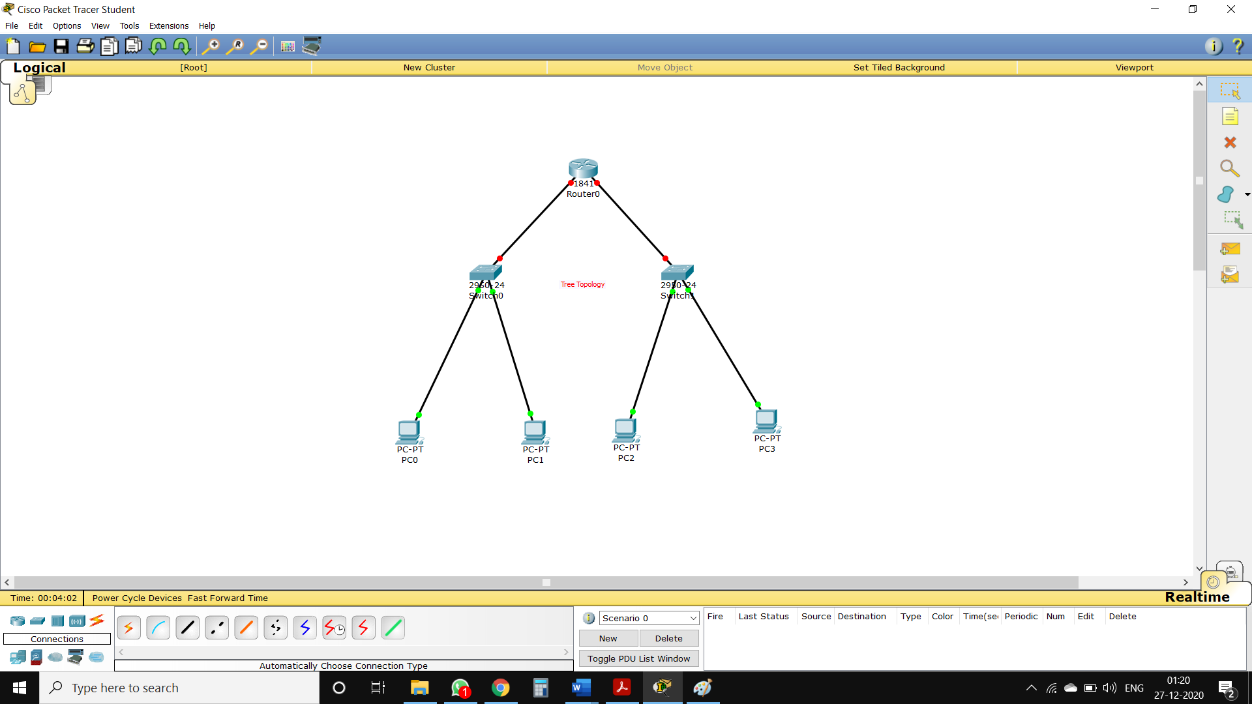

**Hybrid Topology :**

Hybrid topology is an integration of two or more different topologies to form a resultant topology which has many advantages (as well as disadvantages) of all the constituent basic topologies rather than having characteristics of one specific topology.  
Example variants:

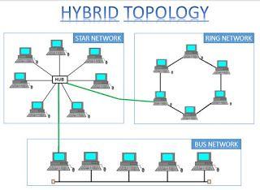 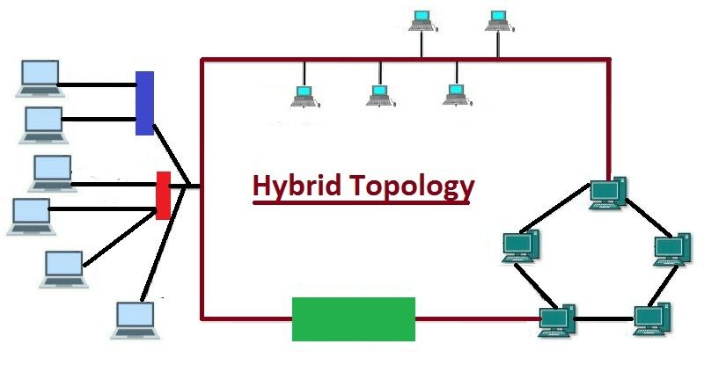

**Advantages of Hybrid topology**

* We can choose the topology based on the requirement for example, scalability is our concern then we can use star topology instead of bus technology.
* Scalable as we can further connect other computer networks with the existing networks with different topologies.

**Disadvantages of Hybrid topology**

* Fault detection is difficult.
* Installation is difficult.
* Design is complex so maintenance is high thus expensive.

Steps: Create any two or more no. of topologies as specified earlier and form a link between them, such that devices in these sub-topologies can communicate.

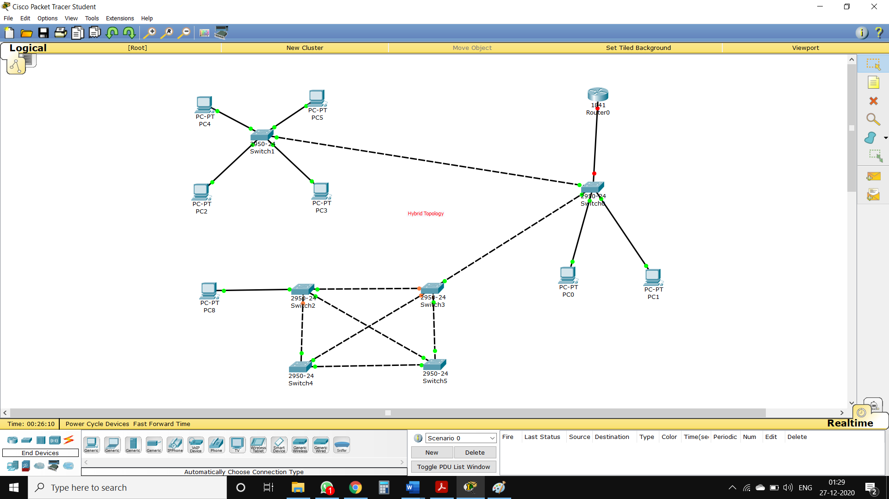

**Conclusion :** Thus we understood and successfully implemented various types of topologies.